34.61: If you move away from the mirror at 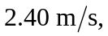 then your image moves away from the mirror at the same speed, but in the opposite direction. Therefore you see the image receding at 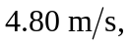 the sum of your speed and that of the image in the mirror.

